**Lab 6: Book Class**

The aim of this lab is to define a set of classes that will be used to represent a Book

For the moment we will assume that books are only written by a single author.

The properties for a book are given below:

* Book – isbn, title, author, genre, publisher and price

We will start by defining the Book class.

Create a new file as you have done before. Call this file bookshop.js. In this file we will first add a Book class definition:

class Book {

    constructor(isbn, title, author, genre, publisher, price) {

      this.isbn = isbn;

      this.title = title;

      this.author = author;

      this.genre = genre;

      this.publisher = publisher;

      this.price = price;

      this.discount = 0.0;

    }

    // Override default toString method

  toString() {

    return (

      "Book(" +

      this.isbn +

      "," +

      this.title +

"," +

      this.author +

      "," +

      this.genre +

      "," +

      this.publisher +

      "," +

      this.price +

      "," +

      this.discount +

      "," +

      ")"

    );

  }

}

This defines a new class Book with a constructor and a toString method.

An example of the test code that these classes should support is given below. This code should be placed after the Book class definition:

console.log("Welcome to the Bookshop");

let author = "Pete Smith";

let publisher = "Tech Books Publishing Ltd.";

let book = new Book(1, "Go Unleashed", author, "Technical",

                    publisher, 15.99);

console.log(book);

console.log(`${book}`);

console.log(book.toString());

Make sure you save the file and then run the program. The output should resemble:

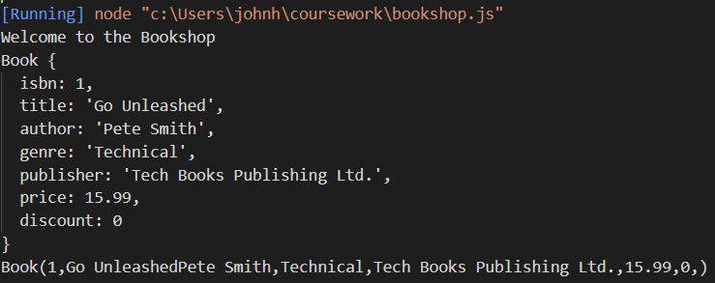

Next we will add a simple method to the book class to provide some additional functional. This function will check to see if the genre of the book is the same as the type we are looking for. To do this we will define a isGenre() method. To do this within the scope of the Book class (but separate from the constructor or the toString method) add the following:

    isGenre(requiredGenre) {

        return this.genre == requiredGenre;

    }

The program should now resemble:

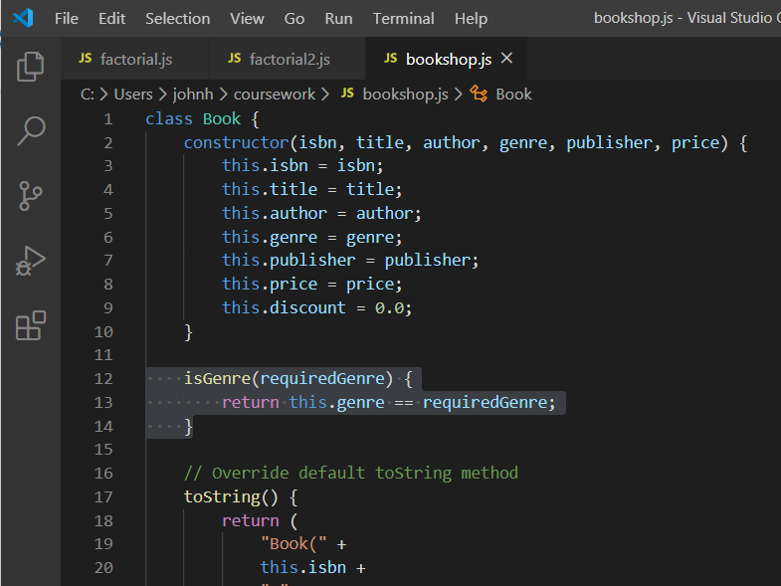

Now in the test code add the following:

console.log(book.isGenre("Technical"));

For example, the test part of the program now looks like:

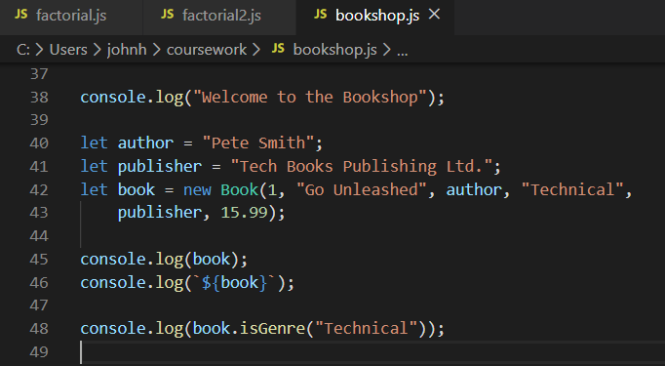

When you run this the value true should be printed out.

Notes

1. Note the difference between the two log statements:

console.log(book);

console.log(`${book}`);

1. The Book class should have a constructor and a toString method
2. Note the difference between the class and an instance of the class